Western Civilization Argumentative Essay
Writing an essay is a process. So it’s going to take time and patience. Don’t think that being a great essay writer is something that happens without knowledge and skill. So the first problem that you must just get over is this process is work.
Argumentative Essay
Makes a claim about a topic and justifies this claim with specific evidence. The claim could be an opinion, a policy proposal, an evaluation, a cause-and-effect statement, or an interpretation. The goal of the argumentative paper is to convince the audience that the claim is true based on the evidence provided.
The Question
If you break up this process over time, keep organized and keep focused it will not seem overwhelming. First off you need to come up with a topic, something that you’re actually interested in (IE Marriage, Technology, and Architecture). Next you will need to formulate a question that comes from this topic. Examples might be,
“Was divorce more common in Roman families or in current families today in the United States?”
“Would Commodus be considered clinically ill by current standards?”
“Was the treatment of animals at the Coliseum better than circus animals today?”
“What was more brutal, the life of a Roman gladiator or detainees at Guantanamo Bay?”
“Who had a greater cultural impact on the world, Julius Caesar or Alexander the Great?”
Research
As you know from your project packet you need to have at least four sources. Where you get these from is up to you. However remember you are now in 10th grade and the quality of your sources must be better and held to a higher standard than Mrs. Brown’s 4th Grade project on Rome. Use MLA or APA style to format your research bibliography.
The Thesis
Your thesis statement should be specific—it should cover only what you will discuss in your paper and should be supported with specific evidence.
The thesis statement usually appears at the end of the first paragraph of a paper.
Your topic may change as you write, so you may need to revise your thesis statement to reflect exactly what you have discussed in the paper.
A good way to write a thesis is to use a word(s) such as “because” or “as a result of” or some other expression because is tells the reader “why” not just “what”.
Example of an argumentative thesis statement:
High school graduates should be required to take a year off to pursue community service projects before entering college in order to increase their maturity and global awareness.
The paper that follows should:
Present an argument and give evidence to support the claim that students should pursue community projects before entering college
The umbrella effect: Thesis over evidence
Writing the Opening Paragraph
The opening paragraph should begin with an introduction. It could be a story, or a set of facts that lead the reader into your answer/thesis. It does not need to be too long because the only part that really matters is the thesis. Writing it well, however, puts the reader in the right frame of mind to read the rest of your essay.
The Body Paragraphs
Each paragraph should become more specific as it develops. The opening paragraph starts with a general introduction and ends with a specific answer to the question. The rest of the paragraphs start with a general topic sentence and ends with specific examples that respond it. Think of paragraphs as inverted pyramids that become more specific and focused as they proceed.
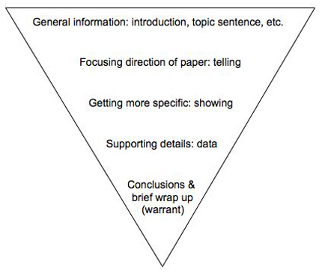
The number of paragraphs in your essay is irrelevant and is determined by the thesis, not some rule created by an English teacher.
A good paragraph should contain at least the following four elements: Transition, Topic sentence, specific Evidence and analysis, and a Brief wrap-up sentence (also known as a warrant) – TTEB!
- A Transition sentence leading in from a previous paragraph to assure smooth reading. This acts as a handoff from one idea to the next.
- A Topic sentence that tells the reader what you will be discussing in the paragraph.
- Specific Evidence and analysis that supports one of your claims and that provides a deeper level of detail than your topic sentence.
- A Brief wrap-up sentence that tells the reader how and why this information supports the paper’s thesis. The brief wrap-up is also known as the warrant. The warrant is important to your argument because it connects your reasoning and support to your thesis, and it shows that the information in the paragraph is related to your thesis and helps defend it.
The Conclusion
Conclusions wrap up what you have been discussing in your paper. After moving from general to specific information in the introduction and body paragraphs, your conclusion should begin pulling back into more general information that restates the main points of your argument. Conclusions may also call for action or overview future possible research. The following outline may help you conclude your paper:
In a general way,
- restate your topic and why it is important,
- restate your thesis/claim,
- address opposing viewpoints and explain why readers should align with your position,
- call for action or overview future research possibilities.
Remember that once you accomplish these tasks, you are finished. Done. Complete. Don't try to bring in new points or end with a whiz bang(!) conclusion or try to solve world hunger in the final sentence of your conclusion. Simplicity is best for a clear, convincing message.

